Day-4 Wipro Pre-Skilling Training
16-12-2025 Assignment-3

Assignment 3.1:-
Design a database schema for any system, including tables, fields, and constraints like NOT NULL, UNIQUE, and CHECK. Include primary and foreign keys to establish relationships between tables.

Simple Library Database Schema:-
1. Book
Attributes
- Book_id (PRIMARY KEY)
- book_name (NOT NULL)
- author (NOT NULL)

2. Member
Attributes
- member_id (PRIMARY KEY)
- member_name (NOT NULL)
- email (UNIQUE)

3. Loan
Attributes
- loan_id (PRIMARY KEY)
- member_id (FOREIGN KEY)
- book_id (FOREIGN KEY)
- loan_date (NOT NULL)
Diagram: - (ER)
Loan M : 1 Member
Loan M : 1 Book
[Member] 1 ---- M [Loan] M ---- 1 [Book]

Assignment 3.2:-
Write SQL statements to CREATE a new database and tables that reflect the library schema you designed earlier. Use ALTER statements to modify the table structures and DROP statements to remove a redundant table.

## Created tables:-
CREATE DATABASE library_db;
USE library_db;
CREATE TABLE book (
book_id INT PRIMARY KEY,
book_name VARCHAR(50) NOT NULL,
author VARCHAR(50) NOT NULL
);
CREATE TABLE member (
member_id INT PRIMARY KEY,
member_name VARCHAR(50) NOT NULL,
email VARCHAR(50) UNIQUE
);
CREATE TABLE loan (
loan_id INT PRIMARY KEY,
member_id INT,
book_id INT,
loan_date DATE NOT NULL,
FOREIGN KEY (member_id) REFERENCES member(member_id),
FOREIGN KEY (book_id) REFERENCES book(book_id)
);
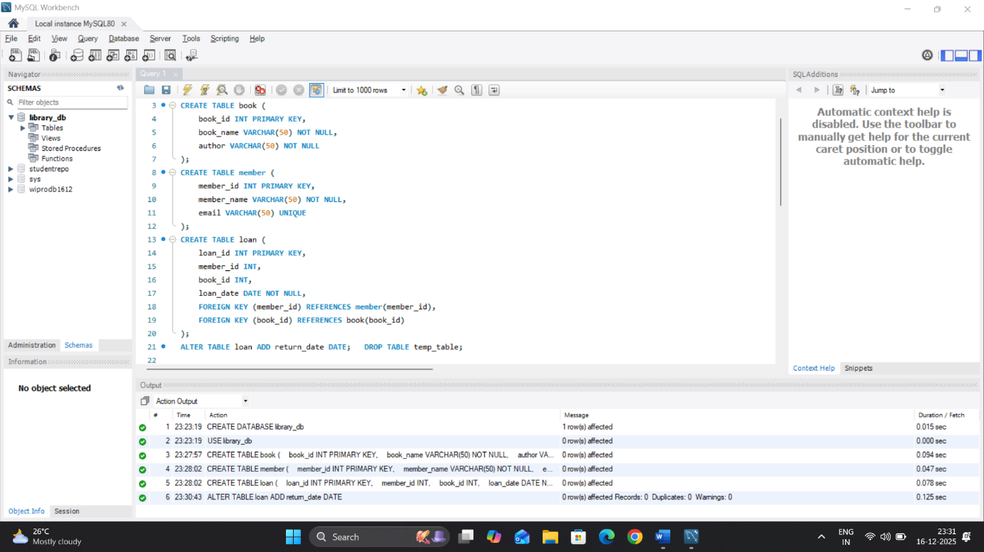

## Alter and Drop operations: -
ALTER TABLE loan ADD return_date DATE;
select * from loan;
create table temp_table (
name varchar(20));
DROP TABLE temp_table;
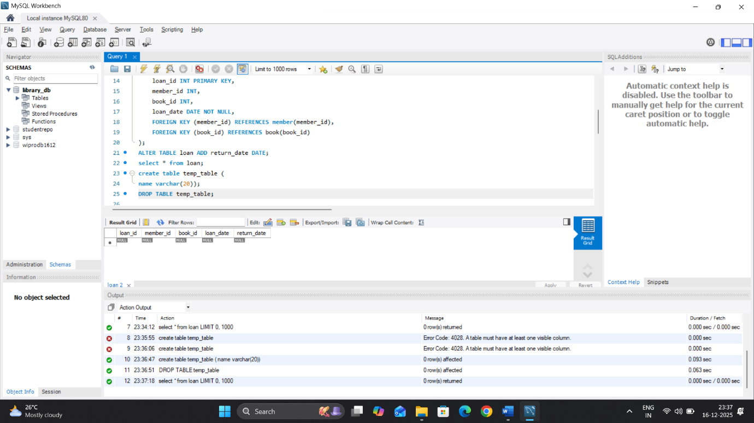
Assignment 3.3:-
Prepare a series of SQL statements to INSERT new records into the library tables, UPDATE existing records with new information, and DELETE records based on specific criteria.
##Inserting records and Updating:
INSERT INTO book VALUES
(1, 'DBMS', 'ak'),
(2, 'SQL', 'Mike');
INSERT INTO member VALUES
(101, 'Avinash', 'avinash@gmail.com');
INSERT INTO loan VALUES
(1001, 101, 1, '2025-01-15', NULL);
UPDATE book
SET book_name = 'RDBMS'
WHERE book_id = 1;
select * from book;
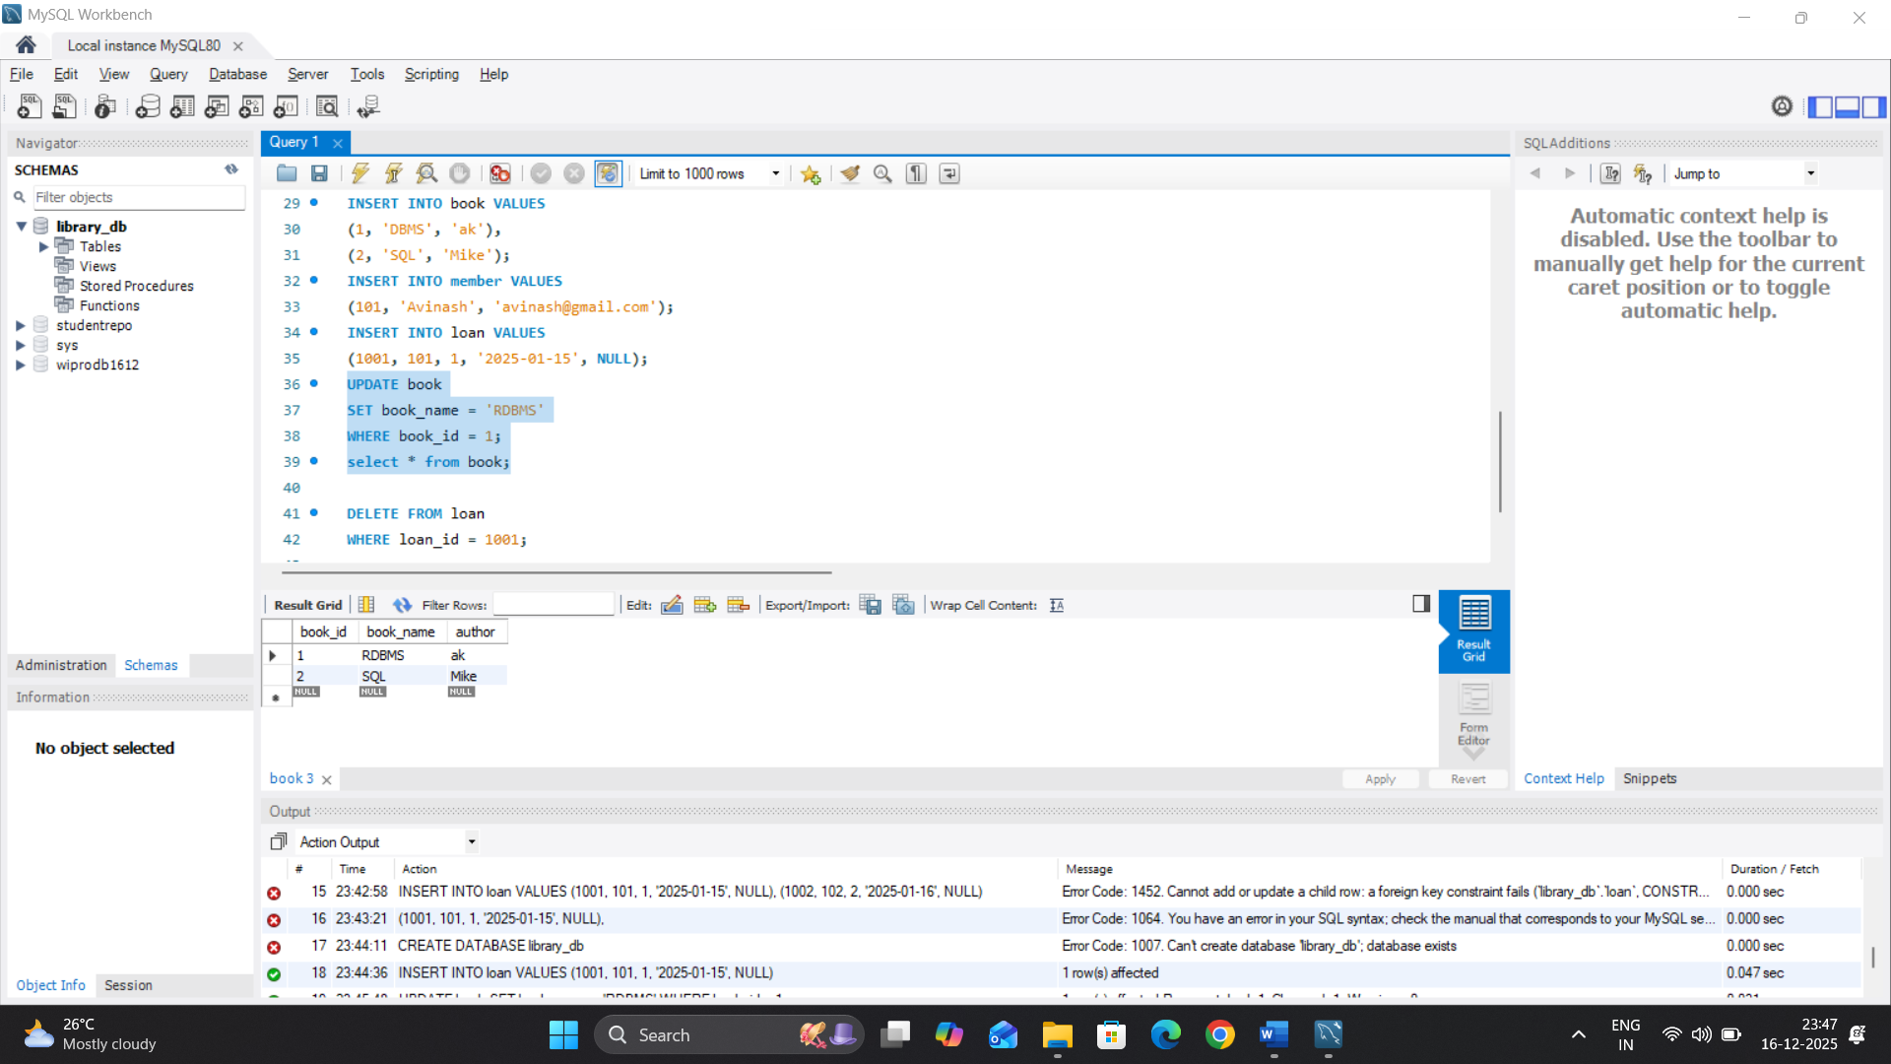
Deleted record from table:-
DELETE FROM loan
WHERE loan_id = 1001;
use library_db
select * from loan;

